Assessment idea

**Elevator pitch**

This project will demonstrate how different behaviors interact in a maze, with a townsperson trying to make their way through the maze whilst a knight is going to be wandering around randomly until it is in range then it will follow the townsperson.

**Movement**

Using an A* library.

I’m going to be utilizing a grid based system to assign node to the paths of my maze to allow the pathfinding algorithm to search through the maze and find a path.

Map

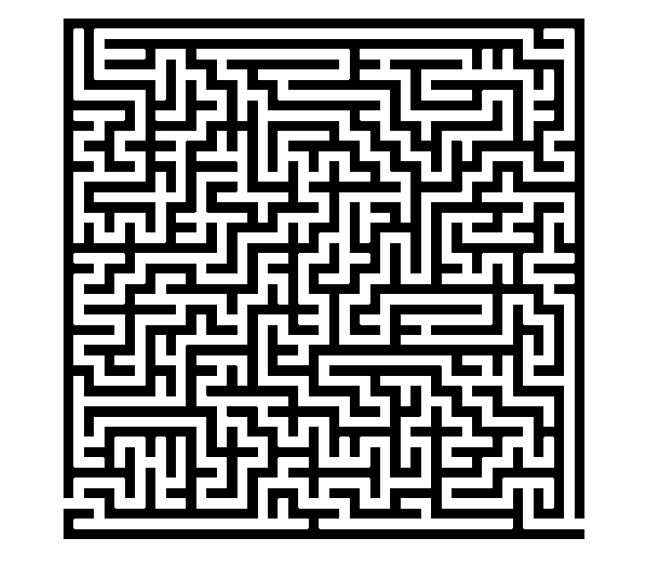

End Point

Start Point

**Agents**

For my project I intend to have two agents in the maze with two separate types of behavior each. The two agents I intend to have will be a trapped townsperson and a knight that is patrolling the maze for intruders.

Townspeople

 

Townspeople - Behaviors

Trying to find its way through the maze from the start point.

Behaviors

- Flee

The townsperson will flee the knight if the knight enters the townspersons inner radius

- Follow path

This will be the default behavior for the townsperson whilst the townsperson isn’t close enough to the knight. The path that the townsperson will follow will be from their current position to the exit of the maze.

Knights

 

Knights - Behaviors

Trying to find the townsperson in the maze.

- Follow

The knight will follow the townsperson if they enter the knight’s radius

- Wander

This will be the default behavior for the knight whilst not able to see the townsperson

Agent Radii

To allow the different agents to interact and change which behavior they are currently using.

Agent

Inner Radius

Outer Radius

Rule for path swaps

|  |  |  |
| --- | --- | --- |
| Townspeople | Flee -> Follow path | Follow path -> Flee |
| Rule for swap | Knight exits the townspersons outer radius | Knight enters the townspersons inner radius |

|  |  |  |
| --- | --- | --- |
| Knight | Follow -> Wander | Wander -> Follow |
| Rule | Townsperson exits the knights outer radius | Townsperson enters the knights inner radius |